Drawing, cutout or picture that represents the word

Part of Speech

**Vocab Word**

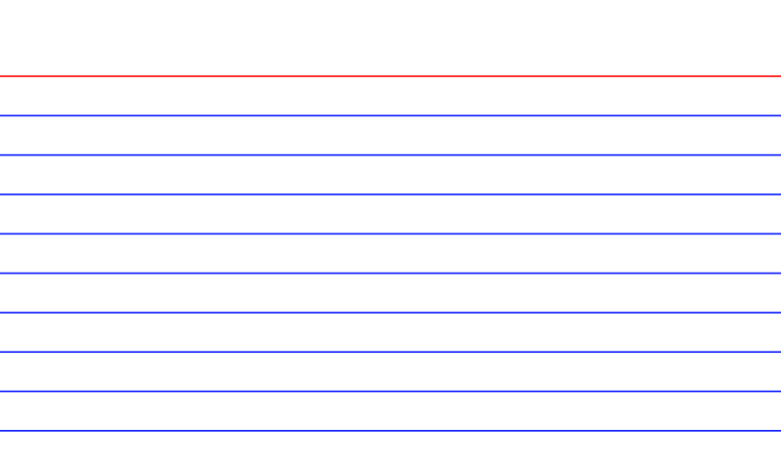

Dictionary Definition

and synonyms

(person/event/song/situation that reminds you of word)

**Antonym**

